**Names: Ishimwe Reine Kelly**

**ID:24016**

WEB TECHNOLOGY PROJECT DOCUMENTATION

**VACATIONAL RENTAL PROPERTY**

Vacation rentals have become an immensely popular lodging option for travelers seeking an alternative to traditional hotels. From cozy beach cottages to lavish urban apartments, owners worldwide are capitalizing on the demand for distinctive short-term rentals.

it provides a way for property owners to reach travelers planning vacations while offering a platform for guests to easily discover and book rentals online. The project leverages web technologies for frontend, backend and infrastructure.

**PROJECT REQUIREMENTS**

1. User Registration

The user registration functionality allows individuals to create an account on the vacation rental system securely. During the registration process, users create their unique login credentials. Upon successful registration and email verification, the system confirms the account creation to the user. The user can now proceed to log in to the system using their registered email and password.

1. Browsing the Vacation Rental Site

The browsing functionality allows users to search for and explore vacation rentals available on the site. Users can navigate through different listings, view rental details, and filter results based on their preferences.

1. Rental Details

When a user clicks on a specific rental listing, the system displays detailed information about the property. This includes additional images, a comprehensive description and amenities

1. Reservation Form

* The system presents a reservation form to the user, requesting the necessary details to complete the booking.

The form typically includes fields such as:

* First Name: The user's first name.
* Last Name: The user's last name.
* Email: The user's email address, which will be used for communication regarding the reservation.
* Number of Guests: The total number of guests accompanying the user during the stay.

**PROJECT IMPLEMENTATION**

Here's an example of how a user navigates the website, starting from the homepage and going through the registration, login, and the reservation form:

1. Homepage:

- When the website loads, the user is directed to the homepage.

- The homepage provides an overview of the vacation rental site and includes featured listings and other relevant information.

2. Navigation to Registration:

- The user decides to register an account on the site.

- They look for a "Register” link/button, located in the navigation menu on the homepage.

- Clicking on the registration link/button redirects the user to the registration page.

3. Registration:

- The registration page displays a form where the user can enter their personal information, including the email and the user’s desired password.

- The user fills out the registration form with the required details and submits it.

- The system validates the form inputs, ensuring that all required fields are filled out correctly and that the email address is in the proper format.

- If any errors are encountered during the validation process, appropriate error messages are displayed to the user.

- If the registration is successful, the user is redirected to the login page.

4. Navigation to Login:

- After successful registration, the user is automatically redirected to the login page.

5. Login:

- On the login page, the user enters their registered email and password in the respective fields.

- The system validates the login credentials and authenticates the user.

- If the login information is incorrect or incomplete, appropriate error messages are displayed.

- If the login is successful, the user is redirected to the reservation form page.

6. Navigation to Reservation Form:

- Once logged in, the user wants to make a reservation.

- The system directs the user to the reservation form, which includes fields such number of guests, their email, their names and any additional information required for the reservation.

- The user fills out the reservation form with the necessary details and submits it.

- The system validates the form inputs, ensuring data integrity and completeness.

**PROJECT PROCESS MODEL RELATIONSHIP**

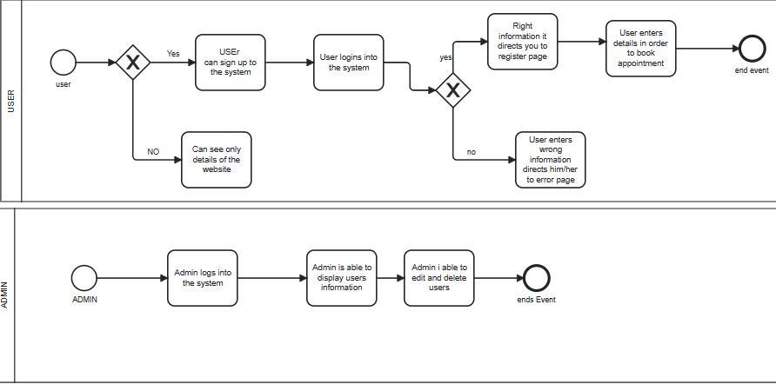

**PROJECT CONSTRAINTS**

Performance and Scalability: Constraints in scalability may lead to slow page loading times, unresponsive features, or system crashes.

Data Backup and Recovery: Constraints may arise if adequate backup and recovery processes are not in place, posing a risk of data loss and prolonged downtime in the event of an unforeseen event.

User Experience: Constraints in delivering an optimal user experience may arise due to limited knowledge or expertise in user interface design, usability testing, or mobile responsiveness. Balancing functionality, aesthetics, and ease of use can be challenging within resource constraints.

**Expected outcomes of this project include**;

Responsive Web Design,

Increased Visibility and Reach,

Streamlined Booking Process and

Performance Optimization.

**Technologies used:**

* Spring Boot
* Spring Data JPA
* Spring Security
* Thymeleaf
* Spring MVC